Related work:

In order to analyze human emotion, a great deal of research has been done. As we already know that there are plenty of ways to recognize emotion, but as we are working with emotion recognition with facial expression, we will review the works related to that.

First of all we should mention Facial Action Coding System (FACS) which was originally developed by Swedish anatomist named Carl-Herman Hjortsjö. [10] Then later developed by Ekman and Friesen in 1978. [11] Facial Action Coding System (FACS) is a system to taxonomies human facial movements from their appearance on the face. [12]

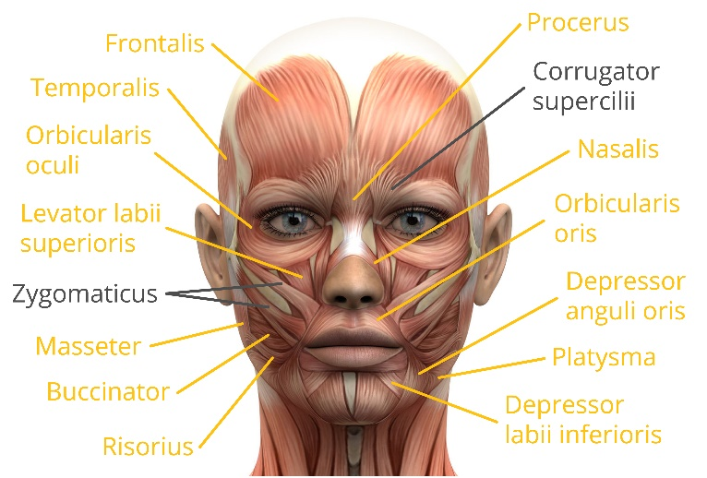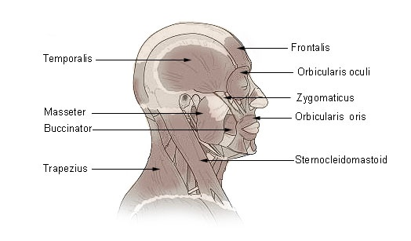

Fig: Wikipedia [12], [17, 18]

FACS defines some Action Units (AUs), which actually refers to the contraction and relaxation of one or more facial muscles.

As an illustration, FACS can classify two types of smiles. [13] Insincere and voluntary Pan-Am smile which is contraction of zygomatic major alone. And another is sincere and involuntary Duchenne smile which is made by contraction of zygomatic major and inferior part of orbicularis oculi. [12] So far this FACS system is being automated and giving promising results. That’s why recently FACS has been proposed for use in analysis of depression. [14]

EMFACS (Emotional Facial Action Coding System) [15] and FACSAID (Facial Action Coding System Affect Interpretation Dictionary) [16] has given a relation between basic human expression and Action Units (AUs).

| **Emotion** | **Action units** |
| --- | --- |
| Happiness | 6+12 |
| Sadness | 1+4+15 |
| Surprise | 1+2+5B+26 |
| Fear | 1+2+4+5+7+20+26 |
| Anger | 4+5+7+23 |
| Disgust | 9+15+16 |
| Contempt | R12A+R14A |

Fig: Wikipedia [12]

The action unit numbers are given in the table. With the number sometimes a letter is associated. Which are A for Trace, B for Slight, C for Marked, D for extreme and E for Maximum. “R” represents an action which occurred on the right side of the face and “L” indicates the left side.

| **AU number** | **FACS name** | **Muscular basis** |
| --- | --- | --- |
| 0 | Neutral face |  |
| 1 | Inner brow raiser | [frontalis](https://en.wikipedia.org/wiki/Frontalis_muscle) ([pars medialis](https://en.wikipedia.org/wiki/Pars_medialis)) |
| 2 | Outer brow raiser | [frontalis](https://en.wikipedia.org/wiki/Frontalis_muscle) ([pars lateralis](https://en.wikipedia.org/wiki/Pars_lateralis)) |
| 4 | Brow lowerer | [depressor glabellae](https://en.wikipedia.org/wiki/Depressor_glabellae), [depressor supercilii](https://en.wikipedia.org/wiki/Depressor_supercilii), [corrugator supercilii](https://en.wikipedia.org/wiki/Corrugator_supercilii) |
| 5 | Upper lid raiser | [levator palpebrae superioris](https://en.wikipedia.org/wiki/Levator_palpebrae_superioris), [superior tarsal muscle](https://en.wikipedia.org/wiki/Superior_tarsal_muscle) |
| 6 | Cheek raiser | [orbicularis oculi](https://en.wikipedia.org/wiki/Orbicularis_oculi) ([pars orbitalis](https://en.wikipedia.org/wiki/Orbital_part_of_frontal_bone)) |
| 7 | Lid tightener | [orbicularis oculi](https://en.wikipedia.org/wiki/Orbicularis_oculi) ([pars palpebralis](https://en.wikipedia.org/wiki/Pars_palpebralis)) |
| 8 | Lips toward each other | [orbicularis oris](https://en.wikipedia.org/wiki/Orbicularis_oris) |
| 9 | Nose wrinkler | [levator labii superioris alaeque nasi](https://en.wikipedia.org/wiki/Levator_labii_superioris_alaeque_nasi) |
| 10 | Upper lip raiser | [levator labii superioris](https://en.wikipedia.org/wiki/Levator_labii_superioris), [caput infraorbitalis](https://en.wikipedia.org/wiki/Levator_labii_superioris) |
| 11 | Nasolabial deepener | [zygomaticus minor](https://en.wikipedia.org/wiki/Zygomaticus_minor) |
| 12 | Lip corner puller | [zygomaticus major](https://en.wikipedia.org/wiki/Zygomaticus_major) |
| 13 | Sharp lip puller | [levator anguli oris](https://en.wikipedia.org/wiki/Levator_anguli_oris) (also known as [caninus](https://en.wikipedia.org/wiki/Caninus)) |
| 14 | Dimpler | [buccinator](https://en.wikipedia.org/wiki/Buccinator) |
| 15 | Lip corner depressor | [depressor anguli oris](https://en.wikipedia.org/wiki/Depressor_anguli_oris) (also known as [triangularis](https://en.wikipedia.org/wiki/Triangularis)) |
| 16 | Lower lip depressor | depressor labii inferioris |
| 17 | Chin raiser | [mentalis](https://en.wikipedia.org/wiki/Mentalis) |
| 18 | Lip pucker | [incisivii labii superioris](https://en.wikipedia.org/wiki/Incisivii_labii_superioris) and [incisivii labii inferioris](https://en.wikipedia.org/wiki/Incisivii_labii_inferioris) |
| 19 | Tongue show |  |
| 20 | Lip stretcher | [risorius](https://en.wikipedia.org/wiki/Risorius) w/ [platysma](https://en.wikipedia.org/wiki/Platysma) |
| 21 | Neck tightener | [platysma](https://en.wikipedia.org/wiki/Platysma) |
| 22 | Lip funneler | [orbicularis oris](https://en.wikipedia.org/wiki/Orbicularis_oris) |
| 23 | Lip tightener | [orbicularis oris](https://en.wikipedia.org/wiki/Orbicularis_oris) |
| 24 | Lip pressor | [orbicularis oris](https://en.wikipedia.org/wiki/Orbicularis_oris) |
| 25 | Lips part | [depressor labii inferioris](https://en.wikipedia.org/wiki/Depressor_labii_inferioris), or relaxation of [mentalis](https://en.wikipedia.org/wiki/Mentalis) or [orbicularis oris](https://en.wikipedia.org/wiki/Orbicularis_oris) |
| 26 | Jaw drop | [masseter](https://en.wikipedia.org/wiki/Masseter); relaxed [temporalis](https://en.wikipedia.org/wiki/Temporalis) and [internal pterygoid](https://en.wikipedia.org/wiki/Medial_pterygoid_muscle) |
| 27 | Mouth stretch | [pterygoids](https://en.wikipedia.org/wiki/Pterygoid_bone), [digastric](https://en.wikipedia.org/wiki/Digastric) |
| 28 | Lip suck | [orbicularis oris](https://en.wikipedia.org/wiki/Orbicularis_oris) |

Fig: Wikipedia [12]

If we look in the table we will see that Happiness consists of Action Unit 6 and 12. That means when cheek is raised and lip corner is pulled, the face will be classified as a happy face according to the FACS. Sometime 25 no. action unit is also associated with a smile which represents a happy face [18].

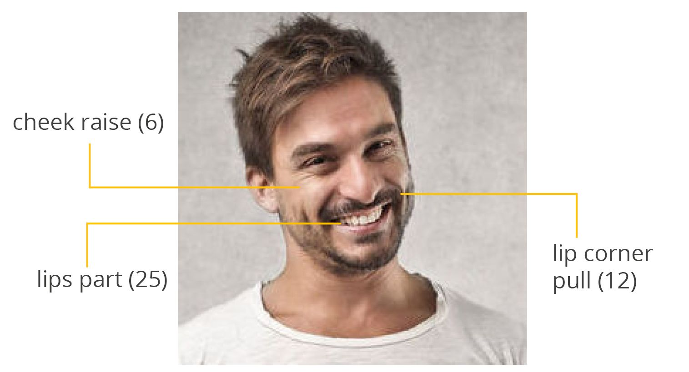

Fig: [18]